Module 6 — How to Keep Farm Accounts in the A2 Format
Today’s entry → tomorrow’s account → the true financial picture of your farming.

1. Learning Objectives
- Understand the practical reasons why farm accounts should be kept.
- Learn how to record farm costs, output and income according to the A2 format.
- Understand how accounts can be kept digitally (GramIQ Krishi Khata) instead of in a paper ledger.

2. Introduction
In all five previous modules of this course, one thing kept coming up — to decide whether MSP is fair, to work out opportunity cost, to find the economic optimum, to benchmark against other farmers and to understand your true daily profit — the foundation of all of these is one: a regular and accurate account of the production cost of farming.
In this final module we will see how exactly to keep this account — what things to record, in which format (the A2 format) to record them, and how, in today’s times, doing this digitally on a mobile phone instead of in a paper ledger makes it easier.

6.1 Why keep farm accounts?
Most farmers try to record expenses in a ledger, diary or on paper. But what actually happens? All the receipts do not stay in one place, the ledger stays somewhere else, some expenses depend only on memory, and some entries get left out altogether.
When the season is over, the questions arise — what was the exact total cost? How much was spent on this crop? How much was the profit compared with the output? It is not enough only to write down costs — it is important that a complete account of those costs is prepared.
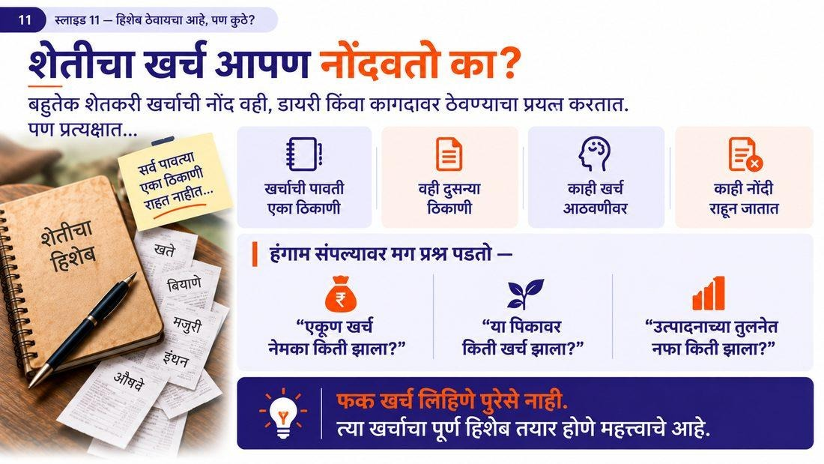
Figure 6.1 — How most farmers record costs, and the difficulties in it
What does keeping accounts give? Proof for demanding the right MSP (Module 1), the ability to measure opportunity cost (Module 2), the possibility of finding your own economic optimum (Module 3), the chance to compare with other farmers (Module 4), and clarity about understanding your true daily profit (Module 5) — all of this comes from one habit: keeping regular accounts.

6.2 What to record in the A2 format?
The A2 format is the record of costs incurred by the farmer for the crop in actual cash or in kind — this is the same format that the government and CACP also use to measure production cost (see Module 1). In every season, for every crop, the following items should be recorded separately:
Table 6.1 — Types of costs to record under the A2 format
Type of cost | What to record
Seed | Quantity and price of seed purchased + estimated value of own saved seed
Fertilisers (chemical + farmyard manure/organic) | Quantity and price of fertiliser used
Pesticides and crop protection | Cost of pesticides, weedicides and fungicides
Hired human labour | Days/hours and wages given for all work (land preparation, sowing, weeding, harvesting, etc.)
Hired machinery / bullocks-animals | Hire charges of tractor, harvester, thresher, sprayer, pump, etc.
Fuel, diesel, electricity | Cost of diesel, electricity and other fuel used for the work
Irrigation charges | Irrigation charges paid (canal, well/borewell, buying water, etc.)
Interest on working capital | Interest paid on crop loan and short-term working capital
Land rent (if land taken on lease) | Cash/in-kind rent of land taken on lease for that crop
Other direct costs | Any other cash/in-kind cost incurred directly for the crop (e.g. transport)

Apart from costs, the following three things should also be recorded regularly for every season: output (the produce obtained from each crop), income (the amount received after selling the produce), and the net profit or loss worked out from these.
Formula for net profit
Net profit = Total income − Total cost (A2)
By working out this same figure per acre, per quintal or per day, all the analysis in Modules 1 to 5 can be done.

Once these three things — cost, output, income — are recorded regularly, clear answers to the following questions are obtained at the end of the season: What was the total cost? How much was the output? How much income was received? How much profit, how much loss? And on the basis of these records, details such as cost of production per acre for each recorded crop, cost of production per quintal, net profit/loss and a crop-wise profit-and-loss statement are also obtained.
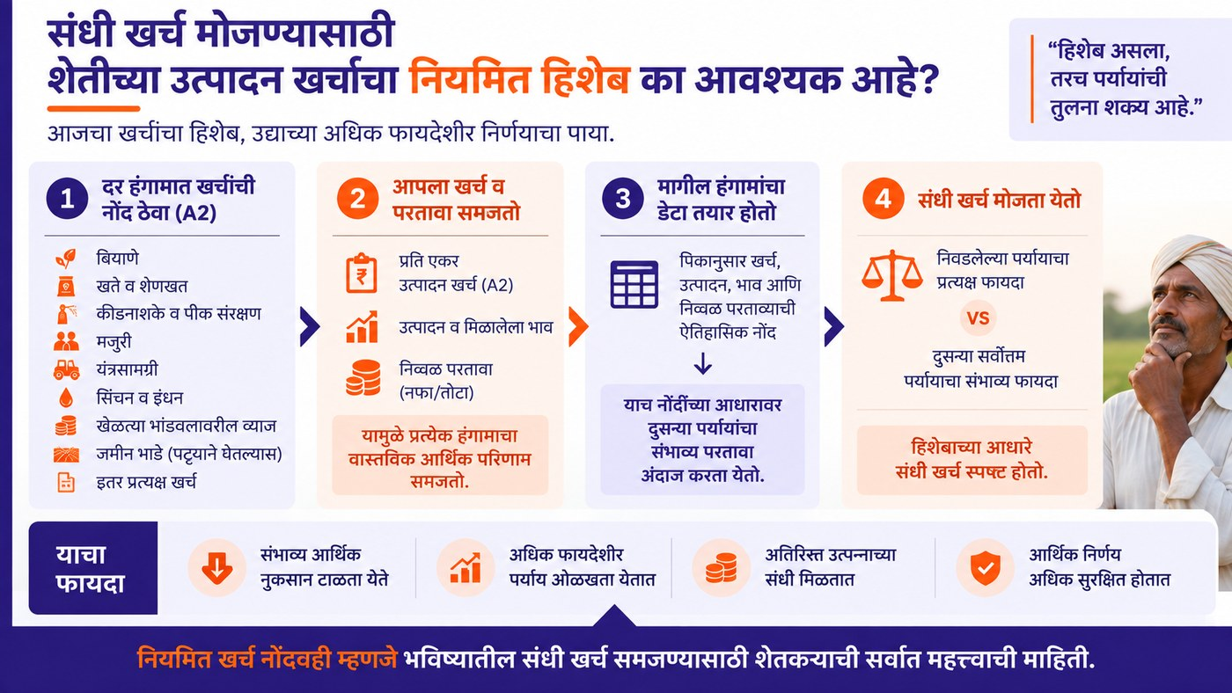
Figure 6.2 — Which questions get answered by keeping regular accounts

6.3 Accounts the digital way — GramIQ Krishi Khata
The habit of keeping accounts does not have to change — only the method has to be made simple. Instead of writing costs in a ledger, diary or on paper, every cost can be recorded on the mobile phone right away. The ledger habit can now be brought onto the mobile — the habit of writing remains the same, only now it becomes more useful.
Just record three things regularly: (1) Cost — seed, fertilisers, pesticides, labour, machinery, etc.; (2) Output — the produce obtained from each crop; (3) Income — the amount received after selling the produce.
At the end of the season you will have a clear answer — how much was the total cost, how much the output, how much the income, and how much the profit or loss. Also, on the basis of your records, details such as cost of production per acre for each recorded crop, cost of production per quintal and net profit/loss are prepared automatically — the question “How much exactly did I spend on my crop and how much did I get?” now gets a clear answer.
To keep this account digitally, the tool GramIQ – Krishi Khata is available: your cost, your data, your decision.
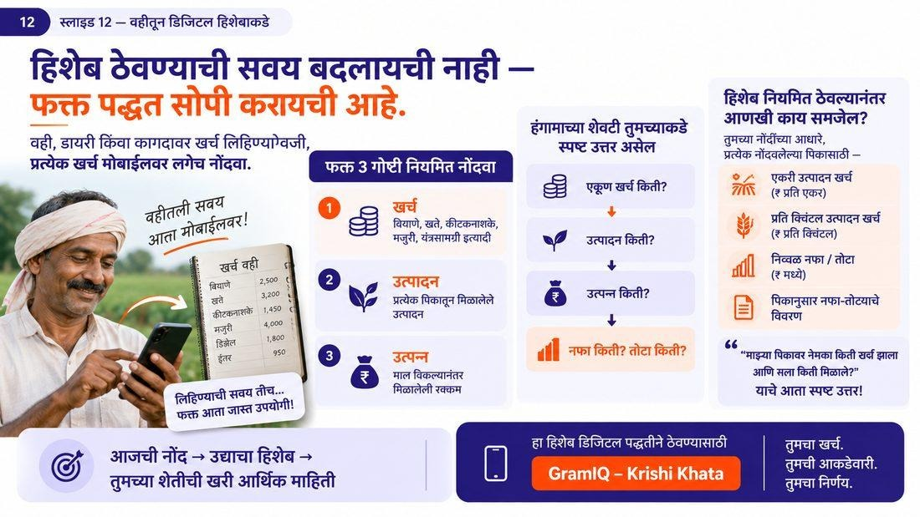
Figure 6.3 — GramIQ Krishi Khata: digital farm accounts on mobile

Key Concepts
- A2 format: the standard method of keeping a record of the costs the farmer incurs in cash/in kind.
- Net profit/loss: the amount remaining after deducting total cost from total income.
- Digital farm accounts: the method of recording costs, output and income through a mobile app.

Key Takeaways
- Record just three things regularly — cost, output and income — and the rest of the account becomes clear automatically.
- The A2 format is the same format the government and CACP also use to measure production cost, so it is useful as proof too.
- Digital records on mobile are safer and more easily available than a paper ledger.
- Every analysis in Modules 1 to 5 (MSP, opportunity cost, economic optimum, benchmarking, tax) becomes possible only through regular accounts.

Review Questions
- Which costs have to be recorded under the A2 format?
- How is net profit worked out?
- What are the benefits of keeping accounts digitally instead of in a paper ledger?

Module Summary
In this module we learned that keeping farm accounts is the foundation of this entire course. If costs such as seed, fertilisers, labour, machinery and irrigation, as well as output and income, are recorded regularly according to the A2 format, the net profit or loss becomes clearly known. With a digital tool like GramIQ Krishi Khata instead of a paper ledger, the record becomes simple, safe and more useful — and this very record helps the farmer to demand a fair price, make sound decisions and understand the true financial condition of his farming.

